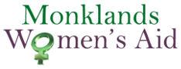Duty of Candour NUL report
All health and social care services in Scotland have a duty of candour. This is a legal requirement which means that when things go wrong and mistakes happen, the people affected understand what has happened, receive an apology, and that organisations learn how to improve for the future.
An important part of this duty is that we provide an annual report about the duty of candour in our services. This short report describes how our service has operated the duty of candour during the time between 1st April 2023- 31st March 2024. We hope you find this report useful.
1. How many incidents happened to which the duty of candour applies?
In the last year, there have been 0 incidents to which the duty of candour applied.
2. Information about our policies and procedures relating to the Duty of Candour:
MWA – Duty of Candour_ Monitoring& Reporting
MWA – Duty of Candour_ SWA Guidance
MWA – Duty of Candour_ Template for Reporting
MWA – Duty of Candour_ Checklist
MWA – Duty of Candour_ Policy & Procedure
Where something has happened that triggers the duty of candour, our staff report this to the service manager who has responsibility for ensuring that the duty of candour procedure is followed. The manager records the incident and reports as necessary to the Care Inspectorate. When an incident has happened, the manager and staff set up a learning review. This allows everyone involved to review what happened and identify changes for the future.
All new staff learn about the duty of candour at their induction. We know that serious mistakes can be distressing for staff as well as people who use our service and their families. We have occupational welfare support in place for our staff if they have been affected by a duty of candour incident.
Where families or children are affected by the duty of candour, we have arrangements in place to provide welfare support as necessary.
We note that Equality Impact Assessments were undertaken of all our policies in procedure on the 09-02-2024.
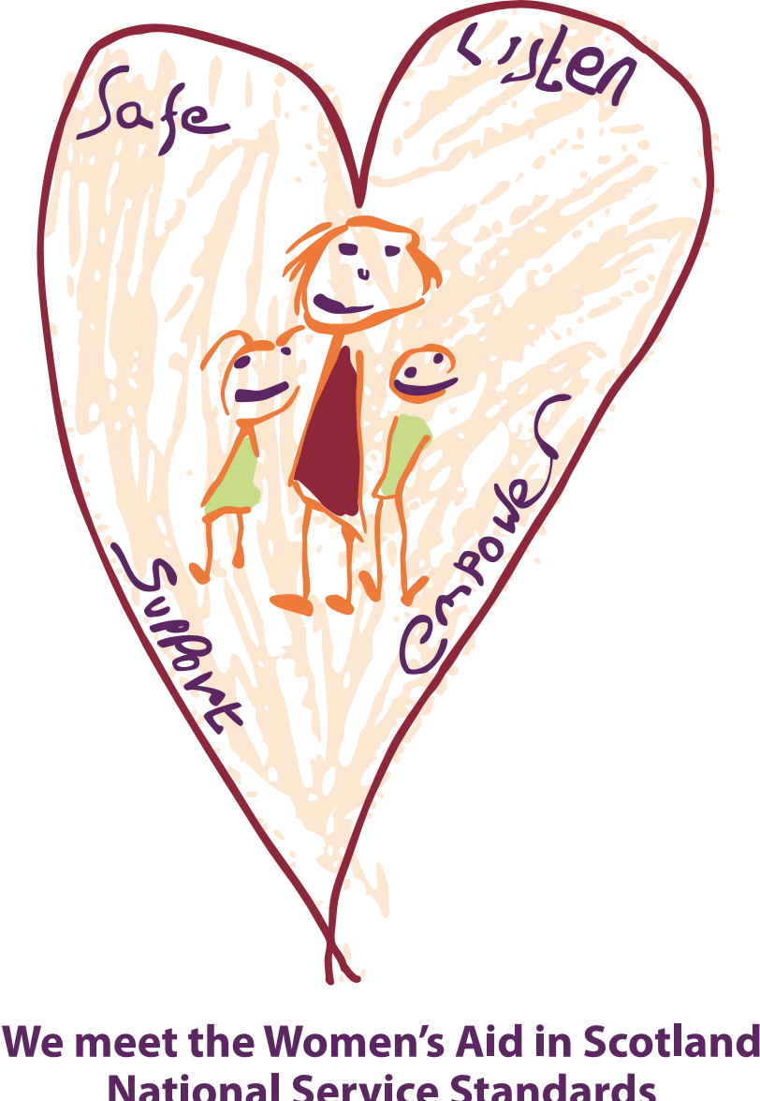
If you would like more information about our service, please contact us: 01236 432061 or info@monklandswomensaid.org.uk

